**ATTACHMENT 1 – Aerial Photo**

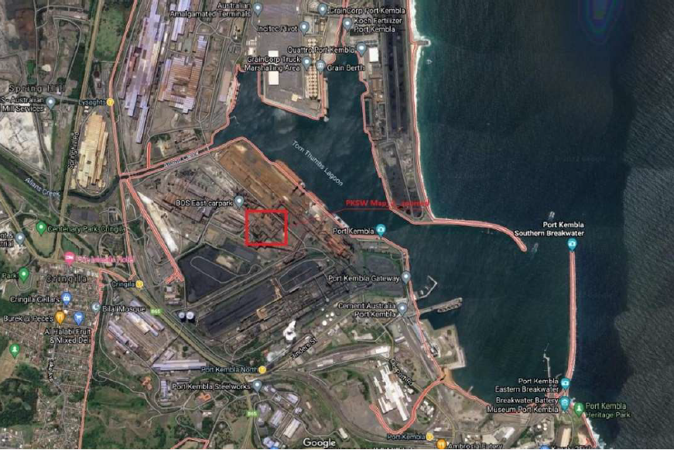

**Aerial Photo showing subject site outlined in red**